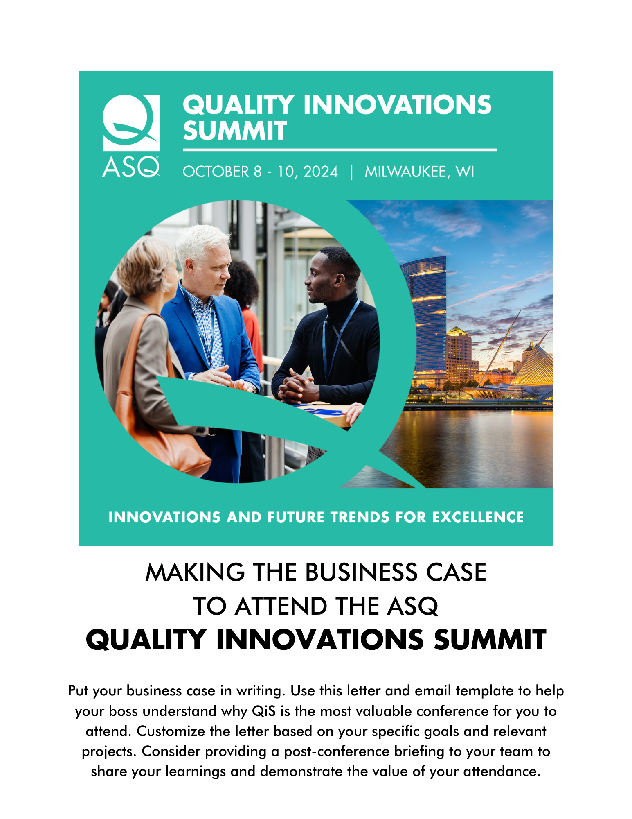

Dear [Insert Manager’s Name],

I’m writing to seek your approval to attend the American Society for Quality’s (ASQ) Quality Innovations Summit (QiS), beginning October 8, 2024.

QiS connects you with Quality Leaders, peers, and like-minded attendees who share your passion for excellence. This event is more than just a meeting point; it's a gateway to becoming part of a vibrant community, committed to exchanging innovative ideas, overcoming challenges, and capturing new opportunities together.

Through QiS’s captivating sessions and thought-provoking discussions, attendees will experience:
- Evolving as a leader by acquiring the necessary skills to effectively address change management, incorporate the voice of the customer, and develop forward-thinking strategies, all while advocating for a culture of excellence within your organization.
- Optimization of the latest trends and preparation in revolutionizing your approach to operations and driving sustainable growth in supply chain management, process automation, risk mitigation, and more.
- Transcending beyond conventional quality strategies and processes, placing greater emphasis on collaboration of advanced technology to foster a human-centric approach and foster sustainability, while breaking down data silos.
The conference offers a significant return on investment – for example, I can see an opportunity to apply what I will learn on [describe project or goal here].

Furthermore, the benefits of fostering a work culture where employees have opportunities to upskill are plentiful. According to LinkedIn Learning, providing these opportunities make employees 3.5 times more likely to believe that their company can help them meet their career goals, contributing to employee retention as well as an energized and engaged workforce. Upskilling is also widely reported to boost employee productivity, according to a PwC survey.

Thanks for considering my request. If able to attend, I’ll be sure to share key takeaways, best practices, and tangible ideas to apply what I’ve learned in order to help our team meet present and future challenges with customized and sustainable quality solutions.

Sincerely,
[Your name]

Subject line: Embrace the Chance to Build a Future of Excellence

Body of email:
Dear [Insert Manager’s Name],

I’m writing to seek your approval to attend the American Society for Quality’s (ASQ) 2024 Quality Innovations Summit (QiS), scheduled from October 8, 2024, through October 10, 2024.

As described in the attached letter, QiS connects you with Quality Leaders, peers, and like-minded attendees who believe that quality is the driving force that leads organizations and individuals to be innovative and pursue excellence.

I’m confident my participation will allow me to bring back proven solutions for our unique organizational needs, helping our team meet the challenges of today and tomorrow.

After reviewing the attached letter, please let me know if you have any questions or if we can discuss further.

Thank you for considering my request,
[Your name]

Learn More and Register

