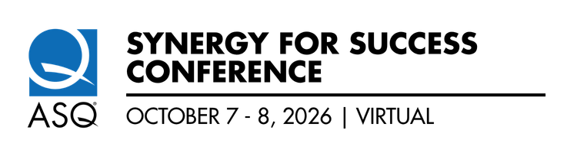

2026 Conference:

Driving Quality and Excellence Across Borders

  - October 7 and 8, 10am to 4pm ET | All Virtual | Complimentary
Mark your calendars and get ready for the ASQ Synergy for Success 2026 Conference, the premier event for quality professionals worldwide! Taking place from **October 7 and 8** from 10am ET to 4pm ET each day, this fully virtual gathering promises to deliver an unparalleled experience, allowing you to connect, learn, and grow—all from the comfort of your home or office.

Why Attend?
Two Fantastic Keynotes:
Wednesday, October 7th, 10am ET – ‘Excellence in the Age of AI: Leadership, Mindset, and the Future of Work Across Manufacturing, Service, and Healthcare’ presented by Dr. Adil Dalal. | 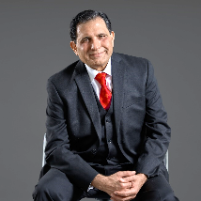
Thursday, October 8th, 10am ET - Defining What’s Next: The Executive EDGe Turning Proven Practices Into Future Advantage’ presented by Dr. Rhonda Farrell. | 

- Collaboration between the following ASQ Technical and Global Communities:
  - ASQ Australia and New Zealand Global Community
  - ASQ Canada and Greenland Global Community
  - EDGe (Energy and Environment, Design and Construction and Government Divisions)
  - Human Development and Leadership Division
  - Lean Enterprise Division
  - Puerto Rico Section
  - Quality Management Division
  - Statistics Division

- Engaging Session Speakers: Gain insights from industry leaders, innovators, and experts on the latest trends, tools, and techniques in quality management. Five concurrent tracks:
  - Cutting EDGe Practices
  - Process Excellence (QMD)
  - Leadership Skills in the Age of AI (ASQ Canada)
  - AI and Lean Practices (Lean Enterprise)
  - The Future of Quality: AI, Analytics, and Operational Excellence (Statistics))
- Global Networking: Collaborate and exchange ideas with peers and thought leaders from diverse industries across the globe.
- Virtual Accessibility: Participate without the need for travel—experience high-quality content at your convenience.
- Actionable Takeaways: Empower your organization with strategies to drive efficiency, excellence, and innovation.
- Earn Recertification Units or CEUs - .5 for attending each day, for a total of 1.0 for the entire conference.

How to Register

https://mp.gg/qy3ktdsuk3

Be Part of the Future of Quality
The ASQ Synergy for Success 2026 Conference is more than an event—it's a movement toward a brighter, more efficient, and innovative future. Together, let’s redefine what quality means in 2026 and beyond.
Join us from **October 7 and 8, 2026**, and let’s create synergy for success!
We look forward to seeing you at the Conference!

